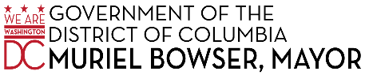
Community Outreach
Event Request Form
Event Name
Event Address
Event is: | Outside Inside |  |  |  |  |  | Ward
Event Date |  |  | Start  Time |  |  |  | End  Time
Event  Contact |  |  | Contact  Position
Contact  Phone |  |  | Contact  Email
Event Type |  | Community Meeting |  | Information Fair |  |  |  | Training
 |  | Panel Discussion |  | Exercise/Fitness |  |  |  | Other
Type of  Audience |  | Senior |  | Youth |  |  |  | Government
 |  | Private Sector |  | Persons with  Disabilities |  |  |  | Non-English or limited English Speaking
 |  | Other:
Expected Audience Size
Translation Services Available |  | Amharic |  |  | Chinese  Mandarin  Cantonese |  |  | French
 |  | Korean |  |  | Spanish |  |  | Vietnamese
Resources Provided by Requestor |  | Tables (No. ) |  |  | DVD/VCR |  |  | Laptop
 |  | Chairs (No. ) |  |  | TV |  |  | Projector
 |  | Other:
Comments
Completed forms can be mailed or emailed.
Email: Robert.mayfield@dc.gov or Ivan.torres@dc.gov
Mail: Attn. - External Affairs and Policy Directorate, HSEMA
2720 Martin Luther King Junior Avenue, SE Washington, DC 20032
*HSEMA will make every effort to accommodate event requests.
However, we ask that all requests be provided at least 10 business days in advance of the event.

